

**ERP APPLICATION QUICK CARDS**

**HOW TO DOCUMENT FOR REFERENCE MODULE**

**.**

Department of Information Resources AFRICA RE-INSURANCE

Management

**TABLE OF CONTENTS**

REFERENCES 2

**A.** **Profit centers** 2

**B.** **I expense category codes** 2

**C. Steps to Run Payroll** 2

D. Defining Receivables Activities 3

E. How to resolve a stuck workflow 4

F. Default Username 4

G. Locked Account 4

H. Payroll 4

I. En dating 5

J. Standard Responsibilities for new staff 5

K. Standard mails to all new staffs 6

L. Unable to Authenticate or Login 7

M. Changing or Resetting Passwords 7

**N.** **Work flow mailer troubleshooter Guide and Key Points** 7

1. Workflow Mailer Notification via email 7
2. Workflow Background process 8
3. Notification Mailers 10
4. Workflow Notifications not getting triggered: 11
5. Failed Notifications 11
6. Debugging steps if Workflow errors out 12
7. Check if the Workflow notification has been sent or not 13
8. How to Resend OPEN, CANCELLED Workflow Notification mails 13
9. Vacation Rules: 14
10. FYI Notifications are Autoclosed 14
11. Metalink References 14

## **REFERENCES**

### **Profit centers**

|  |  |
| --- | --- |
| EAR | East Africa (Nairobi) |
| NAR | North Africa (Casablanca) |
| ARSCA | South Africa (Johannesburg) |
| WES | West Africa (Lagos) |
| CAR | Central Africa (Abidjan) |
| EGY | Cairo |
| MAU | Mauritius |

### **I expense category codes**

|  |  |
| --- | --- |
| **CODES** | **I EXPENSE** **CATEGORY** |
| 10040 | Education tertiary |
| 10063 | Education secondary |
| 10064 | Education primary |
| 10060 | Medical mat local |
| 10061 | Medical mat abroad |
| 10041 | Medical optical |
| 10240 | Medical dentist |
| 10241 | Medical general |
| 10451 | Optical general |
| 10452 | Medical mission |
| 10453 | Medical comp |

### **Steps to Run Payroll**

|  |  |  |
| --- | --- | --- |
| **S**.**No** | **Detail** | **Reports** |
| 1 | Payroll Run | Justification to confirm elements captured as expected. |
| 2. | Prepayments | Bank Summary |
| 3. | Direct Deposit |  |
| 4. | Costing | Costing Detail and Costing Summary |
| 5. | Costing of Payment |  |
| 6. | Transfer to GL |  |
| 7. | Import Payroll Journals | GL Responsibility>> Import Journals>> choose source payroll |
| 8 | Review created journals and post |  |

## **Defining Receivables Activities**

Receivable Activities are used when inputting miscellaneous receipts. They provide accounting information for monies received that don’t relate to invoices or to account customers.

**Responsibilities**: AR Supervisor or AR Manager

**Navigate**: Set up → Receivable Activities

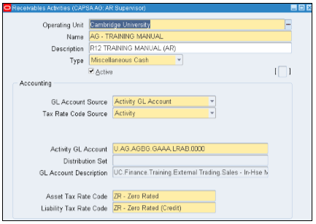

**Enter** thefollowingvalues

**Operating** **Unit:** Cambridge University (defaults in).

**Name:** **Prefix** with your two letter department code followed by hyphen and name of the activity you are creating.

**Description:** Free text field, **enter** details of the activity you are creating.

**Type:** **Click** on the arrow and select **Miscellaneous** **Cash**.

**GL** **Account** **Source:** Activity GL Account defaults in. However, if you require the income to be split to more than one distribution code refer to guidance on Distribution set.

**Activity** **GL** **Account:** **Populate** the Distribution code you wish the income to go to by **clicking** on the list of values.

**Asset** **Tax** **Rate** **Code:** **Select** the appropriate tax code for the activity from the list of values.

**Liability** **Tax** **Rate** **Code:** **Select** the same code as the asset tax rate but it will appear as a credit.

Once all the details have been populated **save** your work and the activity is ready to be used with your miscellaneous receipts.

## **How to resolve a stuck workflow**

**Responsibilities**: System Administrator

**Navigate**: SystemAdministrator **→** Administratorworkflow**→** Workflow **→** Notification**→** StatusMonitor

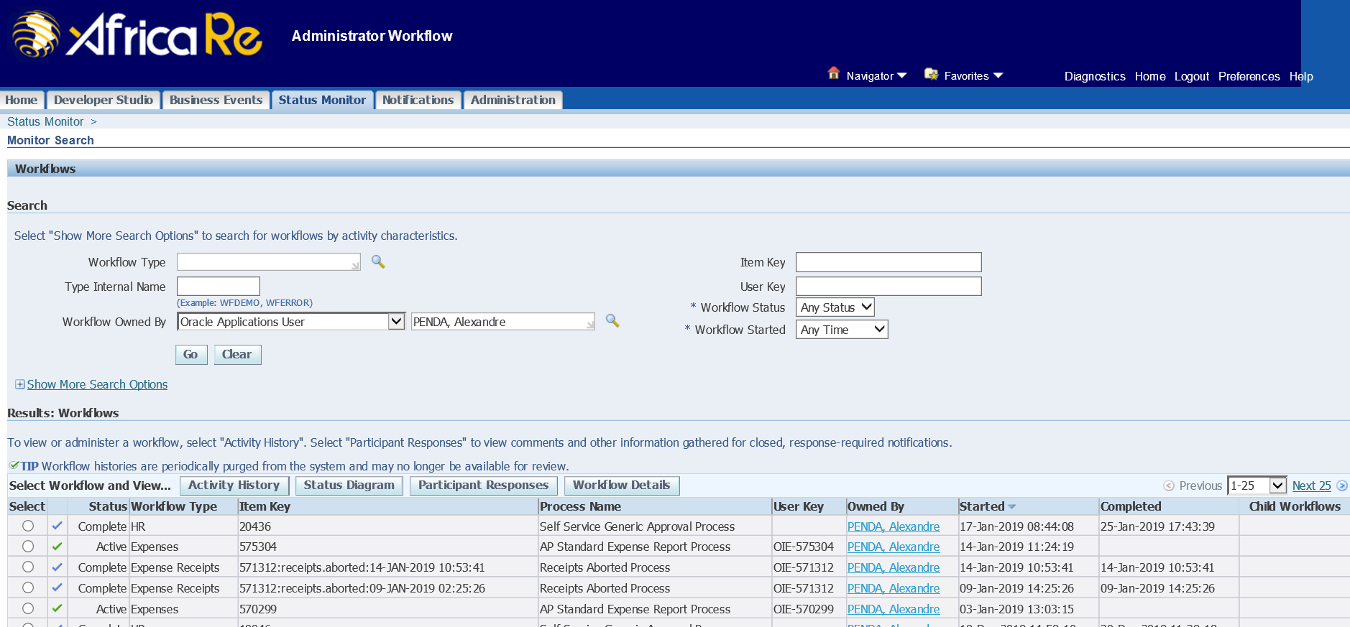

## **Default Username**

The default user name of any user is the (**lastname.firstname**) of that user. This knowledge could be useful, when a user forgets his/her User name.

**Example**.

Abraham.charles

## **Locked Account**

This occurs, when the user, repeatedly inputs the incorrect login details three (3) times. The accounts is automatically locked.

## **Payroll**

**Process for creating Reports**

i. Creation to reports ii. Formula for elements to show up on reports

## **En dating**

## **Standard Responsibilities for new staff**

Please **note** the standard responsibilities for new staff. Kindly **correct** any you have done in the past.

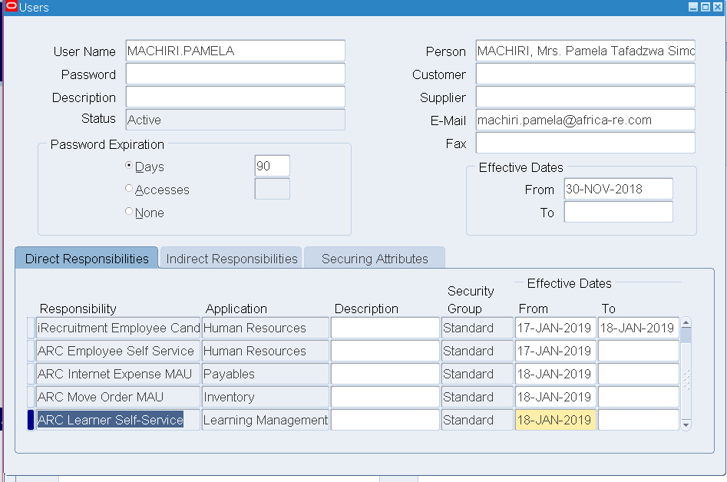

## **Standard mails to all new staffs**

Good afternoon Mr. Tennick,

Welcome to Africa Re.

Your login details for the ERP application are as follows:

Username: **TENNICK.ANDY**

Password: **oracle123** (all small caps)

Link: <http://lagerpapp.arc.local:8010>

You will be required to change your password immediately you login.

Please do not hesitate to contact Lincoln or Samantha if you require any assistance.

Regards,

**Oluwatoyin AROWOLO  |  Manager ICT**

Africa-Re-Logo-RGB for e-mail signature

African Reinsurance Corporation

Société Africaine de Réassurance

Plot 1679 Karimu Kotun Street, Victoria Island, P.M.B.12765 Lagos, Nigeria

**M**: + 234 (0) 807 717 4234**|  T**: + 234 (1) 280 09 24-5 / + 234 (1) 461 68 20/ + 234 (1) 461 68 28  **|** F: + 234 (1) 280 0074  **|  Web Site:** [www.africa-re.com](http://www.africa-re.com/)

**Financial Strength** and **Credit Ratings: A.M. Best Company** : **A** (**Excellent / Stable Outlook**) **|** **Standard & Poor’s** : **A-** (**Strong  / Stable Outlook**)

*Established in 1976 by 36 member States of the African Union and the African Development Bank Group (AfDB), The African Reinsurance Corporation (AFRICA RE), the leading reinsurance company in Africa and the Middle East, is a pan-African financial institution whose shareholding is split between African (75%) and Non-African (25%) investors. African shareholding comprises 41 African states, the AfDB and more than 100 African insurance/reinsurance companies from the 41 member countries. Headquartered in Lagos (Nigeria), Africa Re has a continental network of regional and local offices in Lagos (Nigeria), Casablanca (Morocco), Nairobi (Kenya), Abidjan (Côte d’Ivoire), Ebène (Mauritius), Cairo (Egypt) and Addis Ababa (Ethiopia) as well as two subsidiaries: Africa Re (South Africa) Ltd in Johannesburg and Africa Retakaful Ltd in Cairo*

*(Egypt).*

## **Unable to Authenticate or Login**

**Clear** the cache and **restart** the ERP.

## **Changing or Resetting Passwords**

**Navigation**: Home

Once logged in, at the top right corner of the screen, **select** ‘**Preferences’**.

**Scroll** down to ‘**Change** **Password’.**

Then **fill** in the necessary details

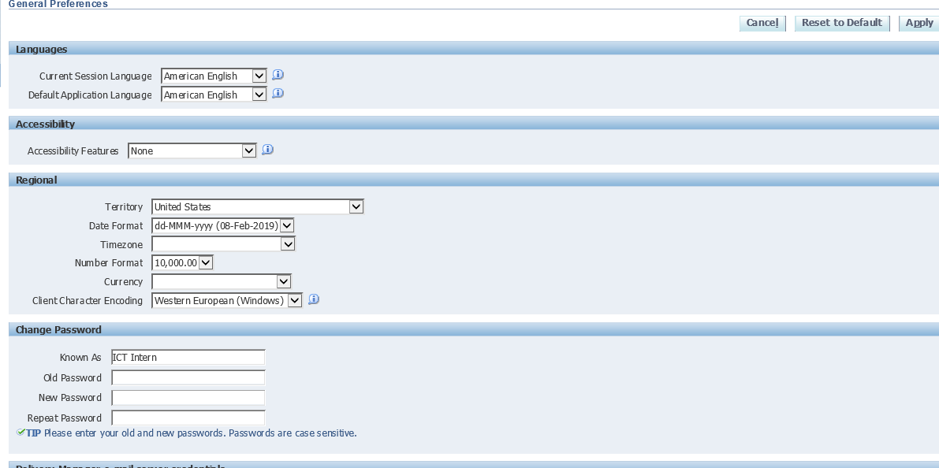

**Click** on the **Apply** button

# **Work flow mailer troubleshooter Guide and Key Points**

**Oracle Workflow**

* Oracle workflow is used to integrate ERP business processes into Oracle applications.
* Oracle workflow is a solution for integrating complete end-to-end business process in ERP.
* Oracle workflow allows people send/receive emails or notifications for approval.

## **Workflow Mailer Notification via email**

The following are the **key** **points** that need to be taken care of if workflow emails are not received for the particular notification:

1. A valid email address should be set for the recipient, for whom the email notification has to be received.
2. The notification preference of the recipient must be ‘**MAILHTML’** i.e ‘**HTML** **Mail** **with** **attachments’**, you can set the same from preferences section once the user login.

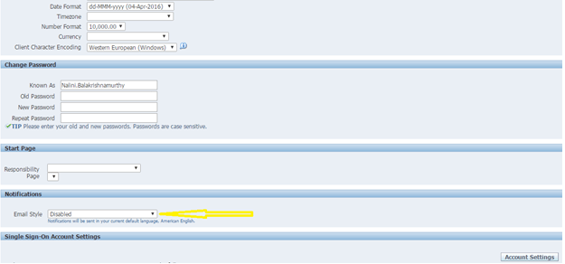

1. You can check the notification preference and email address details from wf_local_roles/wf_roles tables.
2. The workflow notification Mailer should be up and running (Outbound thread count should >=1 and Inbound thread count = 1)

## **Workflow Background process**

* Workflow Background process is the standard concurrent program which should be scheduled for every 10 minutes with the following parameters:
* Y,N,N
* N,Y,N
* N,N,Y

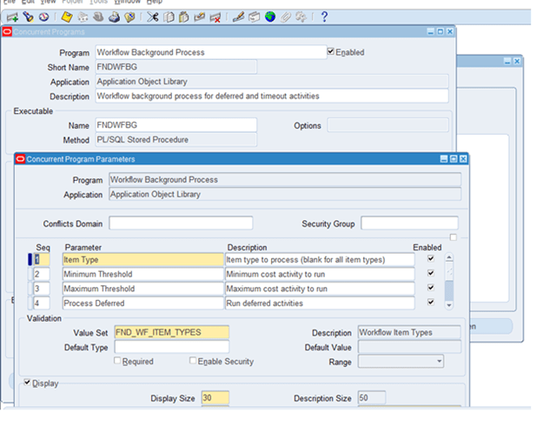

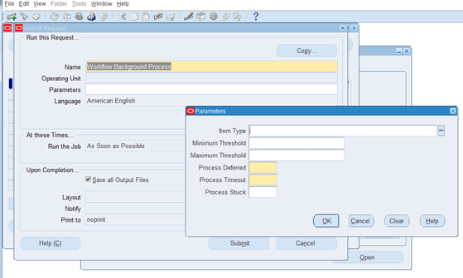

## **Notification Mailers**

* **Check** if all the agent listeners are up and running as shown below:
* **Navigation** **Path**:
  + **Go** **to** ‘**Workflow** **Administrator** **Web** **Applications’** responsibility and **click** on ‘**Workflow** **Manager’** as shown below.

Notification Mailers, Agent Listeners, Background Engines etc., should be up and running

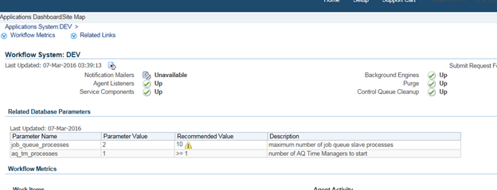

The cause of the workflow issue can be workflow not running or Notifications not being fired.

* If the workflow process is not getting initiated, get the **workflow** **name** and **item** **key**. Item key is a key to identify the workflow instances
* Eg: item key examples

1. **PO Approval Workflow**

* **SELECT** wf_item_key **FROM** po_headers_all
* **WHERE** segment1 = :po_number
* **AND** org_id =  :organization_id ;

1. **Requisition Workflow** –

* **SELECT** wf_item_key **FROM** po_requisition_headers_all
* **WHERE** segment1 = :requisition_number
* **AND** org_id = :organization_id
* With the workflow name and the item key for the workflow which is failed, follow the below steps:

**Go** **to** workflow status monitor

**Enter** the Workflow type and Item key of the workflow

* Status of each workflow can be of Active/Error/Complete/Defferred

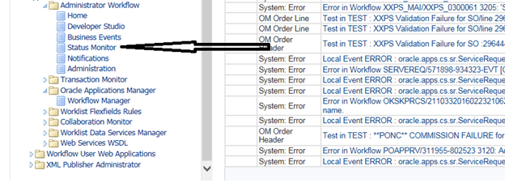

## **Workflow Notifications not getting triggered:**

* 1. All the oracle workflow notifications are stored in the WF_NOTIFICATIONS table.
  2. **SELECT** * **FROM** WF_Notifications **WHERE** notification_id = :notification_id and item_key = :item_key(po_header_id or requisition_header_id);
  3. **Mail_status**:
     1. **Sent**: – Mails are successfully sent to the recipients.
     2. **Error**: – Mails are not delivered to the recipient due to invalid email address.
  4. **Status:** 
     1. **Open**: – Mails are sent to the recipient, but the user not read the email.
     2. **Closed**: – Mail has been viewed by the recipient.
     3. **Error**: – Mail server is not able to deliver the message.
     4. **Cancelled** :- Workflow got cancelled
     5. **Timeout** :- Notification got timed out

## **Failed Notifications**

* 1. If notifications are not received, **check** if record exists in wf_notifications table.
  2. **SELECT** * **FROM** wf_notifications **WHERE** item_key = (Item key from status monitor windlow). **Check** the status and recipient_role values.
  3. Mail_status of the notifications should be ‘**SENT’** for all open notifications. If notification is closed, Mail_Status will be **null**.
  4. Recipient_role should be approver name.
  5. To update the notification_preference from backend.
  6. **UPDATE** wf_local_roles set notification_preference = ‘**MAILHTML’** **WHERE** name = ‘**ASECO**.**DAVID’**

**Tips:**

* 1. **Clear** the cache always if the notifications listed in the notification work list were not able to open.
  2. **Set** the workflow Administrator privilege to **“*”** from sys admin login to view all the workflow status diagrams of all the workflows owned by other users.

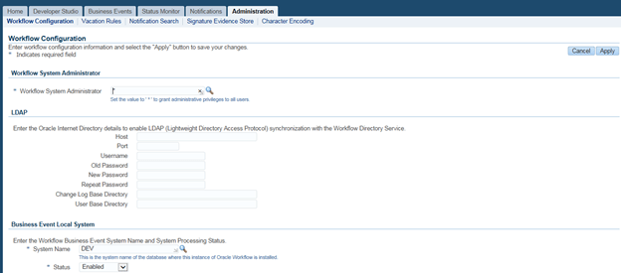

## **Debugging steps if Workflow errors out**

* **Login** a User (with Workflow Administrator responsibility)
* Workflow Administrator -> Administrator Workflow -> Status Monitor-> Enter Type Internal Name (**,POAPPRV, REQAPPRV, XXEFTPYM** )-> Go
* List of workflows will be displayed. **Select** the workflow with respective to Payment batch id.
* **Click** status diagram/Activity History button. Errors can be listed out on the particular activity if any

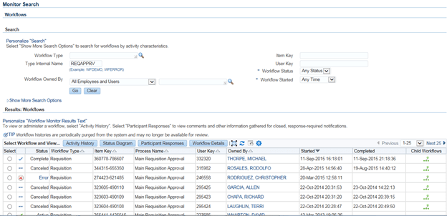

## **Check if the Workflow notification has been sent or not**

* **SELECT** mail_status, status **FROM** wf_notifications **WHERE** notification_id= :notification_id
* If mail_status is **MAIL**, it means the email delivery is pending for workflow mailer to send the email notification
* If mail_status is **SENT**, its means workflow mailer has sent email
* If mail_status is **Null** and status is **OPEN**, then no need to send email as notification preference of user is “**Don’t** **send** **email**”
* Notification preference of user can be set by user by logging in application -> **click** on preference -> the notification preference

## **How to Resend OPEN, CANCELLED Workflow Notification mails**

* Many notification mailers stuck in the mailer queue (status=**’OPEN’** and mail_status=**’MAIL’**)
* SQL> **SELECT** **COUNT**(*) **FROM** wf_notifications **WHERE** status=**’OPEN’** and mail_status=**’MAIL’**;
* **SELECT** notification_id, status, mail_status, subject, **FROM**_user, begin_date **FROM** WF_NOTIFICATIONS **WHERE** status = ‘**OPEN’** and mail_status = ‘**MAIL’**;
* Oracle Workflows notifications cannot be sent due to mail server problems, network problems
* We can resend the notifications by doing the following:

1) Stop workflow mailer

2) Cd $FND_TOP/patch/115/sql

3) Sqlplus APPS/<pwd> @wfntfqup.sql APPS <pwd> APPLSYS

4) Start workflow mailer and monitor the queue

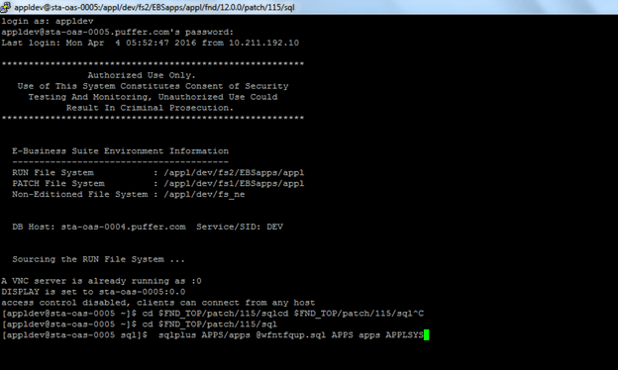

## **Vacation Rules:**

* Vacation rules handle notifications automatically when the users are not available or on vacation/leave to manage their notifications personally. These rules are defined by the user according to the item type for the particular notification. In Oracle Applications, we can control what item types are available for vacation rules using the WF: Routing Rule Item Types lookup type and the WF: Vacation Rules – Allow All profile option.

**Note –** If the reassign button is hidden from the notifications tab, then vacation rule will not function.

## **FYI Notifications are Auto closed**

* If FYI notifications for Approve/Reject has been autoclosed, then Auto close FYI Flag in workflow notification mailer should be set to “**N**”

## **Metalink References**

**Note**: 1054215.1 – How to Check if the Workflow Mailer is running

**Note**: 415516.1 – How to Check Whether Notification Mailer is Working or Not

**Note**: 831982.1 – 11i/R12 – A guide for troubleshooting Workflow Notification Emails – Inbound and Outbound

**Note**: 1012344.7 – Notifications Not Being Sent In Workflow

**Note**: 560472.1 – Workflow Mailers Not Sending Notifications